30054 International and Monetary Economics
Individual Assignment 1 — Solution
Spring 2026

Problem 1 — Data (Italy)

1.1 Latest Annual Data
Country: Italy. Source: ISTAT (Istituto Nazionale di Statistica), National Accounts.
The latest complete annual data available refer to 2023. All figures are in billions of euros at current prices.
Definitions used (from class):
GDP = C + I + G + NX (expenditure approach with net exports)
GNE = C + I + G = GDP − NX (gross national expenditure)
GNI = GDP + NIFA (gross national income)
GNDI = GNI + NUT (gross national disposable income)
2023 values:
GDP = 2,085.0 billion EUR
Trade balance (NX) = Exports − Imports ≈ +5.0 billion EUR
GNE = GDP − NX = 2,085.0 − 5.0 = 2,080.0 billion EUR
NIFA (Net Factor Income from Abroad) ≈ −20.0 billion EUR
GNI = GDP + NIFA = 2,085.0 + (−20.0) = 2,065.0 billion EUR
NUT (Net Unilateral Transfers) ≈ −13.0 billion EUR
GNDI = GNI + NUT = 2,065.0 + (−13.0) = 2,052.0 billion EUR
Note: ISTAT does not report GNE directly. It is computed as GDP minus the trade balance. GNI is available from the income accounts. GNDI is obtained by adding net current transfers to GNI.

1.2 Time Series Plot (1995–2023)
The figure below plots the four aggregates for Italy over the longest available period (1995–2023) at current prices.
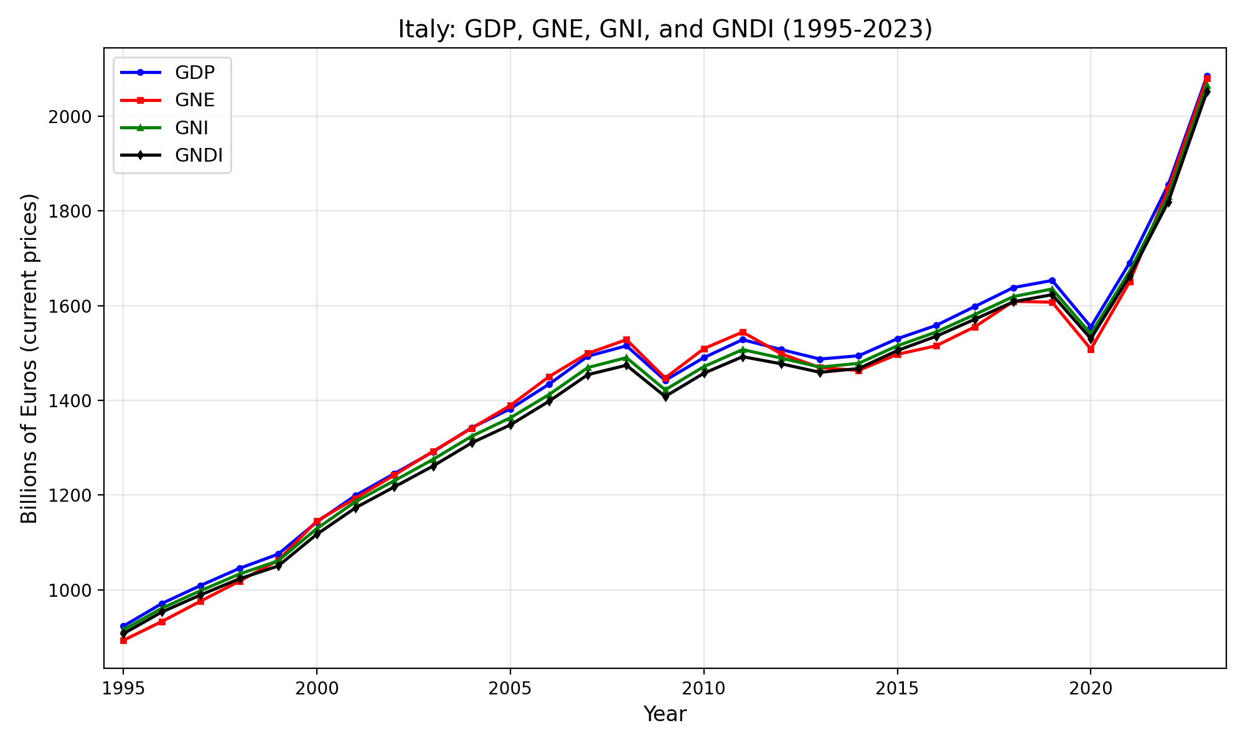
Figure 1: Italy — GDP, GNE, GNI, and GNDI, 1995–2023 (billions EUR, current prices). Source: ISTAT.

1.3 Discussion
(a) GDP vs. GNE
For most of the sample, Italy’s GDP was close to its GNE. In years when Italy ran a trade surplus (NX > 0), GDP > GNE, and vice versa. In the 2000s Italy had trade deficits (especially driven by high energy import costs), so GNE exceeded GDP. After 2012, a combination of improved competitiveness, subdued domestic demand, and lower energy prices shifted Italy into a trade surplus, making GDP slightly above GNE. In 2023, the trade balance was approximately in balance, so GDP ≈ GNE.
(b) GNI vs. GDP
Italy’s GNI has been consistently lower than its GDP. This implies NIFA < 0: foreign factors of production (foreign-owned firms, foreign investors) earn more income in Italy than Italian factors earn abroad. Italy is a net debtor country with a negative NIIP, so it pays more investment income to foreigners than it receives. The gap has widened somewhat as foreign ownership of Italian government debt and corporate assets has grown.
(c) GNDI vs. GNI
Italy’s GNDI has been consistently lower than its GNI. This reflects negative NUT: Italy is a net contributor to the EU budget (through the common agricultural policy, structural funds, etc.) and Italian migrants’ remittances outward exceed inward remittances. The gap is relatively stable at around 10–15 billion EUR per year.

Problem 2 — Balance of Payments (Ikonomia)
Given:
CA = −$1,000 million (current account deficit)
FA(nonreserve) = +$750 million (surplus, i.e., net capital inflow)
KA = +$100 million (surplus)
Income of Ikonomian factories abroad = $700 million
Trade deficit: NX = −$800 million
NUT = 0 (no unilateral transfers)
GDP = $9,000 million

2.1 Change in Net Foreign Assets
The change in net foreign assets (NFA) equals the current account balance:
ΔNFA ≈ CA = −$1,000 million
Ikonomia’s net foreign assets decreased by $1 billion during 2010. The country lost foreign assets (equivalently, it increased its net indebtedness to the rest of the world).

2.2 Official Settlements Balance (OSB)
The BOP identity requires:
CA + FA + KA = 0
where FA = FA(nonreserve) + FA(reserve). The official settlements balance is:
OSB = CA + KA + FA(nonreserve)
OSB = −1,000 + 100 + 750 = −$150 million
Since OSB < 0, the central bank’s foreign reserves decreased by $150 million. The central bank had to sell foreign reserves to finance the gap between the current/capital account deficit and private capital inflows.
Equivalently, from the BOP identity:
FA(reserve) = −(CA + KA + FA(nonreserve)) = −(−1,000 + 100 + 750) = +150
FA(reserve) = +$150 million means net inflow of reserves (the central bank sold foreign reserves worth $150 million to domestic or foreign agents, constituting a capital inflow into Ikonomia).

2.3 Income of Foreign Factors in Ikonomia
The current account is:
CA = NX + NIFA + NUT
−1,000 = −800 + NIFA + 0
NIFA = −$200 million
NIFA is defined as:
NIFA = Income(domestic factors abroad) − Income(foreign factors at home)
−200 = 700 − Income(foreign factors in Ikonomia)
Income(foreign factors in Ikonomia) = $900 million

2.4 Net Factor Income from Abroad (NIFA)
NIFA = −$200 million
Ikonomia pays $200 million more to foreign factors than it receives from its factors abroad.

2.5 BOP = CA + FA + KA = 0
Total FA:
FA = FA(nonreserve) + FA(reserve) = 750 + 150 = $900 million
Verification:
BOP = CA + FA + KA = −1,000 + 900 + 100 = 0 ✓

2.6 GNE, GNI, and GNDI
GNE:
GNE = GDP − NX = 9,000 − (−800) = $9,800 million
GNI:
GNI = GDP + NIFA = 9,000 + (−200) = $8,800 million
GNDI:
GNDI = GNI + NUT = 8,800 + 0 = $8,800 million

Problem 3 — Exchange Rate, UIP and CIP
Given:
Initial investment: €1,000
R(GB) = 2% (British one-year deposit rate)
R(NL) = 4.04% (Dutch one-year deposit rate)
Forward rate: F = 1.575 €/£
Spot rate: E = 1.5 €/£

3.1 Euro-Denominated Return on Dutch Deposits
Return = €1,000 × (1 + R(NL)) = €1,000 × 1.0404 = €1,040.40
Euro-denominated return = 4.04%.

3.2 Riskless Euro-Denominated Return on British Deposits (with Forward Cover)
Step 1: Convert euros to pounds at the spot rate:
€1,000 / 1.5 = £666.67
Step 2: Invest in British deposit at 2%:
£666.67 × 1.02 = £680.00
Step 3: Convert back to euros using the forward rate:
£680.00 × 1.575 = €1,071.00
Using the exact CIP return formula:
(1 + R(GB)) × F/E = 1.02 × (1.575/1.5) = 1.02 × 1.05 = 1.071
Riskless euro-denominated return on British deposits = 7.1%.

3.3 Arbitrage Opportunity
Yes, there is an arbitrage opportunity. The covered return on British deposits (7.1%) strictly exceeds the return on Dutch deposits (4.04%). An investor can:
(i) Borrow in the Netherlands at 4.04%.
(ii) Convert to pounds at the spot rate, invest in a British deposit at 2%.
(iii) Sell the pound proceeds forward at F = 1.575 €/£.
(iv) Earn a riskless profit of 7.1% − 4.04% = 3.06%.
This is NOT an equilibrium in the forward exchange rate market because covered interest parity (CIP) does not hold. In equilibrium, arbitrage would drive the forward rate to a level where the covered returns are equalized.

3.4 Equilibrium Forward Rate (CIP)
CIP requires:
1 + R(NL) = (1 + R(GB)) × F/E
F = E × (1 + R(NL)) / (1 + R(GB))
F = 1.5 × 1.0404 / 1.02 = 1.5 × 1.02 = 1.53 €/£
Equilibrium forward rate: F = 1.53 €/£.

3.5 Forward Premium on the British Pound
Using F = 1.53 (from CIP):
Forward premium = (F − E) / E = (1.53 − 1.5) / 1.5 = 0.03 / 1.5 = 2%
The forward premium is positive: the pound trades at a 2% premium in the forward market. This is because the British interest rate (2%) is lower than the Dutch rate (4.04%). Investors accept the lower British rate because they are compensated by the expected/forward appreciation of the pound. In CIP equilibrium, the forward premium exactly offsets the interest rate differential, eliminating arbitrage.

3.6 Expected Depreciation of the Euro (UIP)
Using the exact UIP condition:
1 + R(NL) = (1 + R(GB)) × Eᵉ / E
Eᵉ / E = (1 + R(NL)) / (1 + R(GB)) = 1.0404 / 1.02 = 1.02
Expected depreciation of the euro:
(Eᵉ − E) / E = 1.02 − 1 = 2%
The euro is expected to depreciate by 2% against the pound over one year.
Intuition: UIP implies the same result as CIP here because, under UIP, the expected future spot rate plays the same role as the forward rate. The higher Dutch interest rate is offset by the expected depreciation of the euro.

3.7 Expected Euro–Pound Exchange Rate
Eᵉ = E × 1.02 = 1.5 × 1.02 = 1.53 €/£
Expected spot rate one year ahead: Eᵉ = 1.53 €/£.
Under UIP, the expected future spot rate equals the CIP-implied forward rate. The euro is expected to weaken from 1.5 to 1.53 per pound.

Problem 4 — Inflation Across a Monetary Union
Context: The West African CFA franc (XOF) is pegged to the euro and used by eight WAEMU states (Benin, Burkina Faso, Guinea-Bissau, Ivory Coast, Mali, Niger, Senegal, Togo). The peg has been maintained since 1999 at 1 EUR = 655.957 XOF.
Data source: IMF World Economic Outlook database, average consumer price inflation (annual percent change).

Observations
1. CFA franc zone countries have significantly lower inflation than the Sub-Saharan Africa average. Over the past two decades, average inflation in Sub-Saharan Africa has typically ranged from 8–15% (and sometimes higher for individual countries), while WAEMU member states have generally maintained inflation between 1–4%.
2. Inflation in the CFA zone is closer to Eurozone inflation levels than to Sub-Saharan Africa levels, though it does not match them exactly.
3. Within the CFA zone, there is some cross-country variation, but all members maintain relatively low and stable inflation compared to the broader Sub-Saharan group.

Explanation
The hard peg to the euro (and before it, the French franc) imposes a strong nominal anchor on the CFA zone economies:
(i) Monetary policy discipline: The West African Central Bank (BCEAO) cannot pursue independent monetary expansion. The peg constrains money supply growth, which in turn constrains inflation. This eliminates the possibility of seigniorage-driven inflation that affects many Sub-Saharan economies.
(ii) Purchasing power parity linkage: Under a fixed exchange rate, relative PPP implies that the domestic inflation rate must approximately equal the foreign (Eurozone) inflation rate plus any changes in the real exchange rate. Since the peg is credible and maintained, CFA inflation tends to track Euro-area inflation.
(iii) Imported credibility: The peg effectively imports the ECB’s anti-inflationary credibility. Economic agents in the CFA zone expect low inflation because they know the central bank cannot monetize fiscal deficits, which anchors inflation expectations.
(iv) Residual differences: The remaining gap between CFA inflation and Eurozone inflation reflects local supply shocks (food prices, oil), differences in the consumption basket, and Balassa-Samuelson effects (nontradable goods prices growing faster in developing economies with rapid productivity growth in tradables).

Problem 5 — Real Exchange Rate
The real interest rate parity condition (derived from UIP and the definition of the real exchange rate) states:
r − r* = (qᵉ − q) / q
where r is the domestic real interest rate, r* is the foreign real interest rate, q is the real exchange rate (domestic currency per foreign currency), and qᵉ is the expected future real exchange rate.

5.1 Hong Kong vs. Singapore
Given: r(HK) = 5%, r(SNG) = 2%.
Let q = real HK$/SNG exchange rate (HK$ per Singapore dollar). Hong Kong is the home country.
r(HK) − r(SNG) = (qᵉ − q) / q
5% − 2% = (qᵉ − q) / q
(qᵉ − q) / q = +3%
The real HK$/SNG exchange rate is expected to rise by 3%. Since q is measured as HK$ per SNG dollar, an increase in q means the Hong Kong dollar depreciates in real terms against the Singapore dollar. Equivalently, Singapore goods become relatively more expensive.
Intuition: The higher real return in Hong Kong compensates investors for the expected real depreciation of the HK dollar. If the HK dollar were not expected to depreciate, all investors would prefer HK assets, driving down the HK real interest rate.

5.2 United States vs. Europe
Given: r(US) = 9%, r(EU) = 3%.
Let q = real $/€ exchange rate (dollars per euro). The US is the home country.
r(US) − r(EU) = (qᵉ − q) / q
9% − 3% = (qᵉ − q) / q
(qᵉ − q) / q = +6%
The real $/€ exchange rate is expected to rise by 6%. The dollar is expected to depreciate in real terms against the euro by 6% over the next year. European goods will become relatively more expensive in dollar terms.
Intuition: The substantial US real interest rate premium (6 percentage points) must be offset by an expected real depreciation of the dollar. Otherwise, capital would flow into the US, appreciating the dollar and lowering US real returns until parity is restored.

Problem 6 — Shifting Curves (DD-AA Model)

6.1 The DD Curve
Mathematical expression:
The goods market equilibrium condition defines DD:
Y = D(EP*/P, Y − T, I, G) = C(Y − T) + I + G + NX(EP*/P, Y − T)
Solving for Y as a function of E (holding P, P*, T, I, G fixed):
Y = Ŷ(EP*/P, T, I, G)
This defines an upward-sloping relationship between E and Y in the (Y, E) plane.
Intuition: The DD curve is the set of all (Y, E) combinations for which the goods market is in equilibrium, i.e., output equals aggregate demand. It slopes upward because a higher exchange rate E (domestic currency depreciation) improves net exports via the real exchange rate channel, raising aggregate demand and thus equilibrium output.

6.2 Shifts of the DD Curve
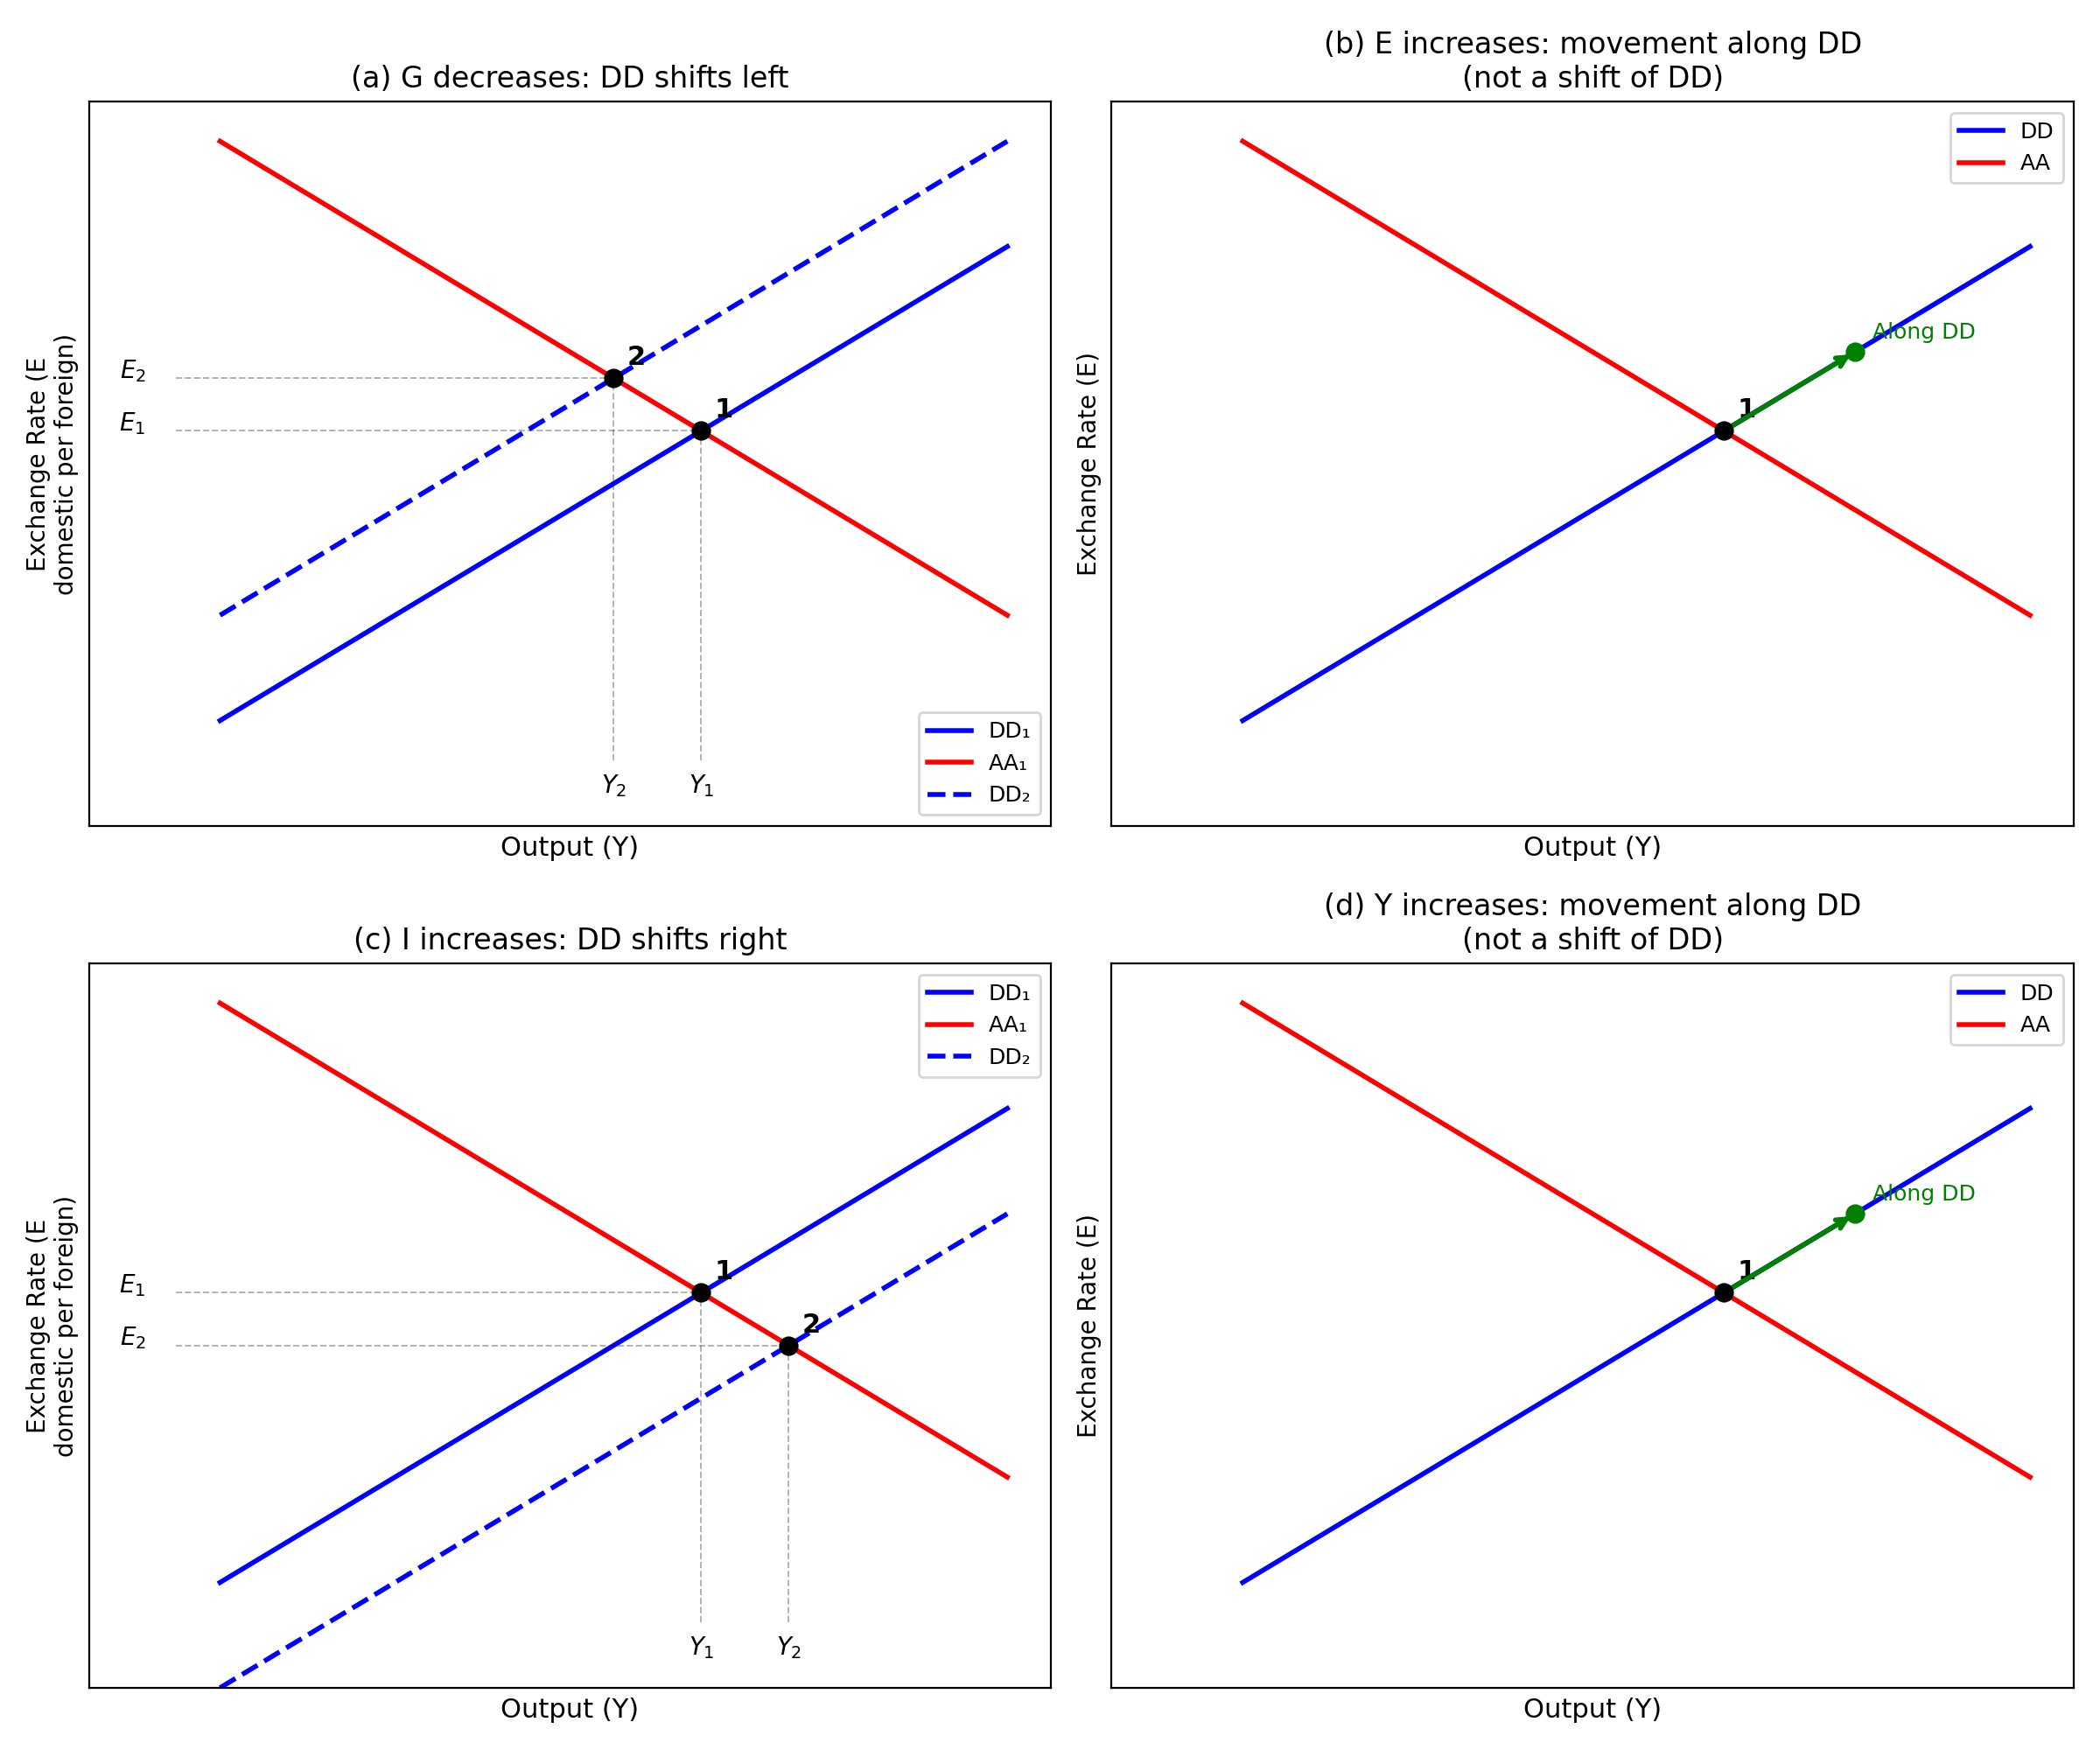
Figure 2: DD curve — shifts and movements along.
(a) G decreases: DD shifts left (equivalently, up).
A decrease in government spending reduces aggregate demand at every exchange rate level. For any given E, the equilibrium Y is lower. This means the DD curve shifts to the left. Equivalently, for any given Y, a higher E (more depreciation) would be required to generate enough net export demand to compensate for the fiscal contraction. The new equilibrium (point 2) has lower Y and higher E (depreciation).
(b) E increases: movement along the DD curve (no shift).
E is on the vertical axis of the DD diagram. An increase in E is simply a movement along the DD curve from one point to another. Since DD describes how Y and E co-move in goods market equilibrium, a change in E traces out a new point on the same curve. No shift occurs.
(c) I increases: DD shifts right (equivalently, down).
An increase in private investment raises aggregate demand at every exchange rate level. For any given E, equilibrium Y is higher, so DD shifts to the right. The new equilibrium has higher Y and lower E (appreciation), because higher output raises money demand, increases the interest rate, and attracts capital inflows that appreciate the currency.
(d) Y increases: movement along the DD curve (no shift).
Y is on the horizontal axis. An exogenous increase in output represents a movement along the DD curve (and likely a disequilibrium if it is not driven by a change in demand). The DD curve itself does not shift; only the point on it changes.

6.3 The AA Curve
Mathematical expression:
The AA curve combines money market equilibrium and the UIP condition:
Mˢ/P = L(R, Y) (money market equilibrium)
R = R* + (Eᵉ − E)/E (uncovered interest parity)
Combining these two conditions and solving for E as a function of Y:
E = Ê(Y, Eᵉ, R*, P, Mˢ)
This defines a downward-sloping relationship between E and Y.
Intuition: The AA curve is the set of all (Y, E) combinations for which both the money market and the foreign exchange market are simultaneously in equilibrium. It slopes downward because an increase in output Y raises money demand, which (given fixed Mˢ/P) raises the domestic interest rate R. A higher R makes domestic assets more attractive, causing a capital inflow and an appreciation of the domestic currency (lower E via UIP).

6.4 Shifts of the AA Curve
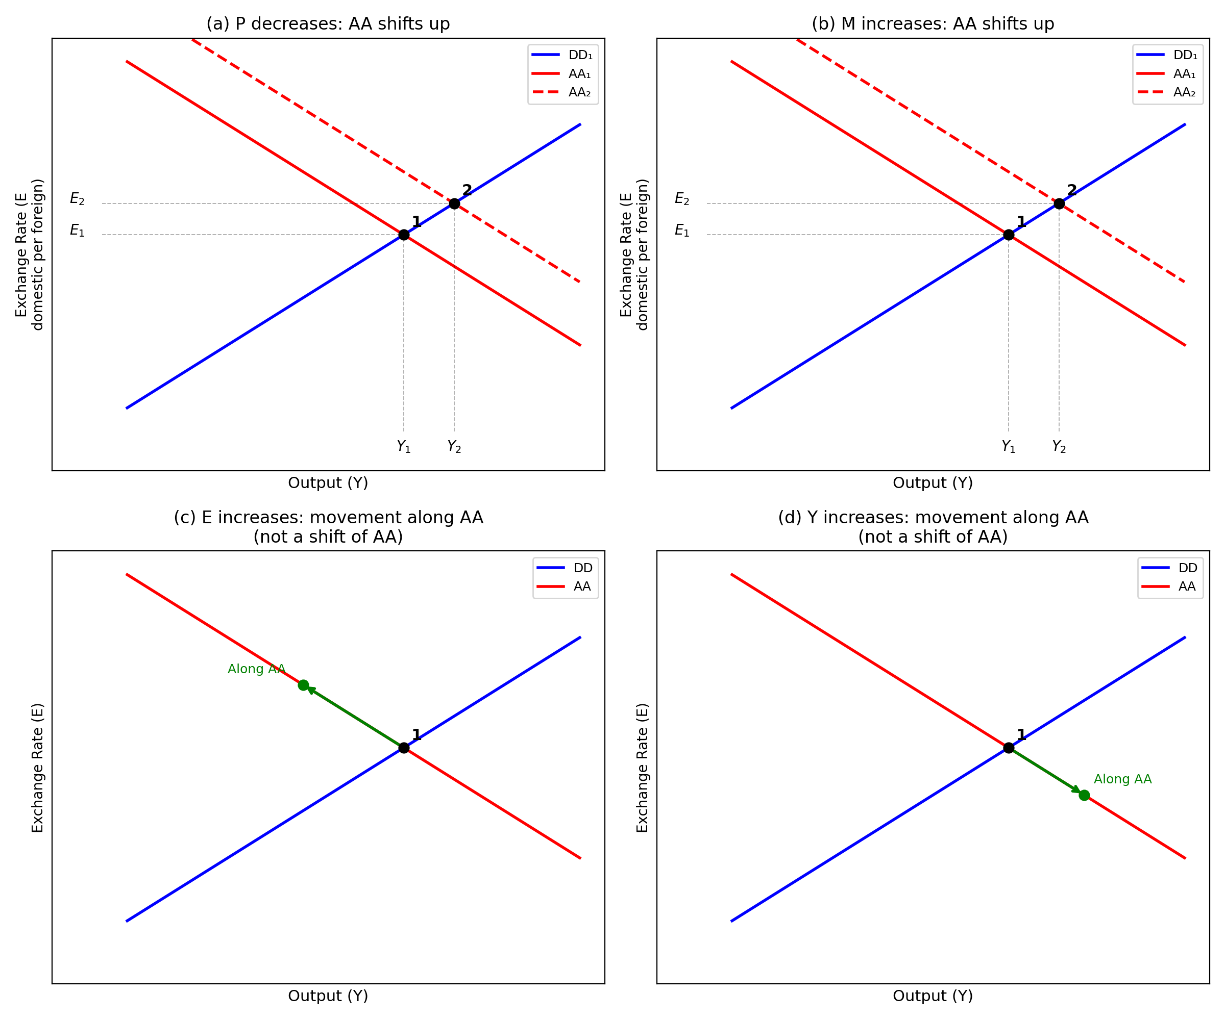
Figure 3: AA curve — shifts and movements along.
(a) P decreases: AA shifts up.
A decrease in the nominal price level P raises the real money supply Mˢ/P. For any given Y, there is now excess supply of real money balances, which pushes the interest rate R down. By UIP, a lower R implies that the domestic currency must depreciate (E rises). Hence, for every Y, the equilibrium E is higher: AA shifts up. The new equilibrium has higher Y and higher E.
(b) Mˢ increases: AA shifts up.
An increase in money supply has the same qualitative effect as a decrease in P: it raises Mˢ/P, lowers R, and causes depreciation (higher E) at every level of Y. AA shifts up. This is the standard expansionary monetary policy result: output rises and the currency depreciates.
(c) E increases: movement along the AA curve (no shift).
E is on the vertical axis. An increase in E is a movement along the AA curve. The asset market equilibrium conditions (money market + UIP) trace out a locus in (Y, E) space; moving to a different E simply selects a different point on this locus.
(d) Y increases: movement along the AA curve (no shift).
Y is on the horizontal axis. An increase in Y causes a movement along the AA curve. As Y rises, money demand increases, R rises, and the domestic currency appreciates (E falls)—this is exactly the downward slope of AA being traced out.

6.5 Shift vs. Movement Along: General Principle
A variable causes a shift of a curve if it is an exogenous parameter of that curve’s equilibrium condition but does not appear on either axis. A variable causes a movement along the curve if it is one of the two variables plotted on the axes (E or Y in the DD-AA framework).
In the DD-AA model, the axes are Y (horizontal) and E (vertical). Therefore:
• Changes in E or Y: always cause movements along both DD and AA (no shift).
• Changes in G, I, T, P*: shift the DD curve (they affect goods market equilibrium but are not on the axes).
• Changes in Mˢ, P, Eᵉ, R*: shift the AA curve (they affect asset market equilibrium but are not on the axes).
This parallels the standard microeconomic distinction between shifts of a supply/demand curve (caused by exogenous variables) and movements along a curve (caused by changes in price or quantity).

